Cognizant Deep Nurture 4.0

Algorithms And Data Structures

**Candidate Name:** Rohit Tudu  
**Superset ID:** 6393839

**Exercise 2: E-commerce Platform Search Function**

**Scenario:**

You are working on the search functionality of an e-commerce platform. The search needs to be optimized for fast performance.

**Steps:**

1. **Understand Asymptotic Notation:**
   * Explain Big O notation and how it helps in analyzing algorithms.
   * Describe the best, average, and worst-case scenarios for search operations.
2. **Setup:**
   * Create a class **Product** with attributes for searching, such as **productId, productName**, and **category**.
3. **Implementation:**
   * Implement linear search and binary search algorithms.
   * Store products in an array for linear search and a sorted array for binary search.
4. **Analysis:**
   * Compare the time complexity of linear and binary search algorithms.
   * Discuss which algorithm is more suitable for your platform and why.

**Solution Checklist (For Theory Check Markdown file)**

1. Theoretical Part in the Markdown file
2. Implemented Linear and Binary Search Algorithms

**Screenshots**

**Main.java**

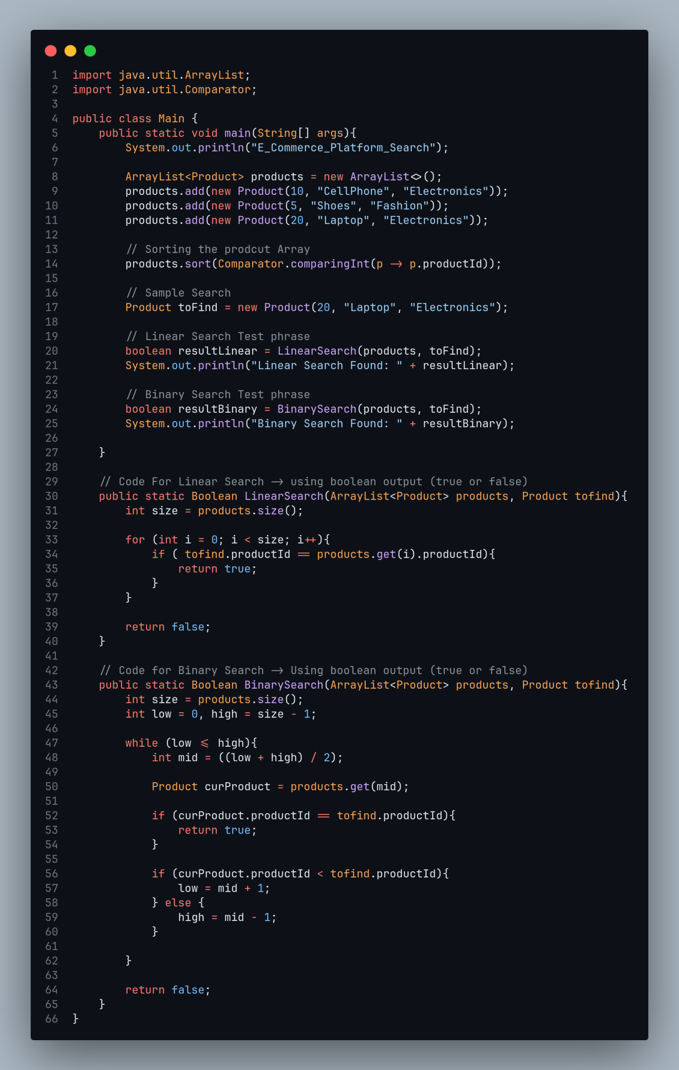

**Product.java**

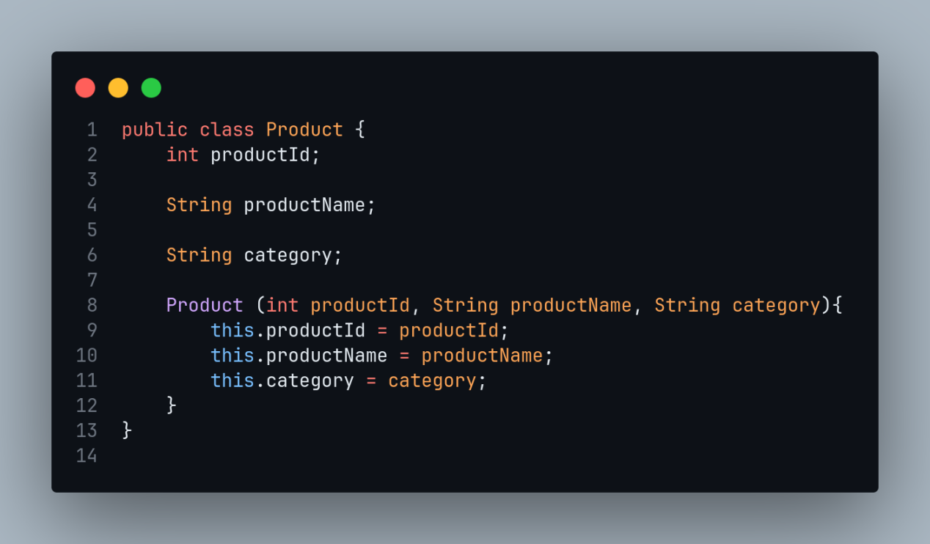

**Output:**

